
Email Management Tips for Faculty
Emory Psychiatry & Behavioral Sciences

- Do, defer, delegate, or delete

  - Every email that comes in can be separated into things you can do quickly, things that should be set aside for when you have more time, things that can be passed along to someone else to handle, or things that can be deleted.
    - Emails can be deferred by categorizing them, placing them into a folder, creating a task (by using the Follow Up Flag), or Snooze (web app only)
    - For example, I place all emails that I need to respond to in my “Pending” folder and review that folder every day

- Rule over your inbox, don’t let it rule you

  - Create a rule for emails that clutter your inbox so they can be immediately sorted. For instance, make a rule for newsletter emails that moves incoming newsletters to a folder called “Newsletters”

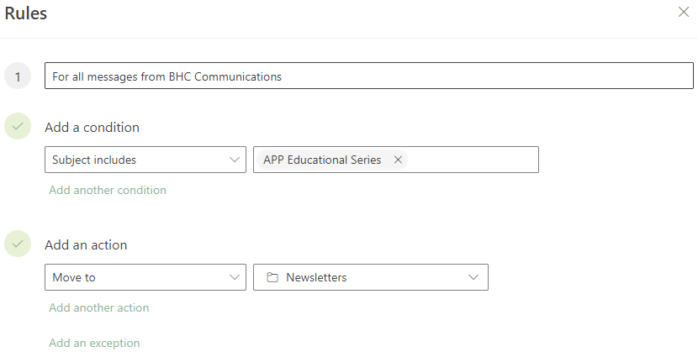

  - Other good uses for rules:
    - Categorizing: Emails from specific people or with specific keywords can be categorized with a color. For instance, all emails from your lab members or pertaining to a research grant can be categorized as “Research” and/or assigned a color. You can then quickly filter your inbox to only include these emails.
    - Forwarding: Emails can be automatically forwarded. For instance, emails that include the keyword “Reimbursement” could be auto-forwarded to the individual who handles reimbursement for your team.

- Set boundaries and expectations

  - Consider including “no reply necessary” in emails that do not need a response.

  - To reduce stress on the recipient, consider adding tag line on non-urgent/non-time sensitive requests:
    - If you are receiving this email on weekends or after hours, I do not expect a response until your working hours.
    - This isn’t urgent so get to it whenever you can.

  - Consider using tags and code words to convey urgency
    - Emails that are urgent can be tagged High Importance and/or labeled with “URGENT:” in the subject line. This should be used infrequently for high priority emails only, such as a grant signoff deadline. If response is required that day or within 24 hours, consider also reaching out via phone call, text, or Teams message, as well
    - Emails that require action can be labeled with “Action:”
    - Emails that are informative only can be tagged Low Importance and/or labeled with “FYI:” in the subject line

  - When following up on a non-response to an email that requires a response, indicate a specific date of when you need to hear back and an assumption of what a nonresponse means

  - Emails can be scheduled for delayed delivery to occur during working hours.

Web:
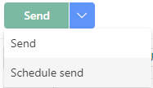

Desktop:
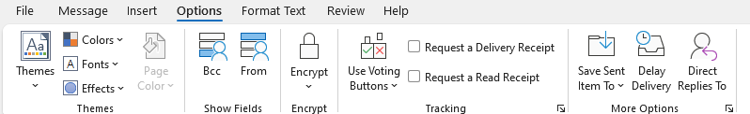
- Play well with others

  - Use OneDrive files instead of attaching a file so your collaborators can review/edit the same document instead of dealing with the headache of multiple attachments

- Stop lost emails

  - Outlook allows you to track tasks that you set for yourself with the To Do pane.

Web: Desktop:
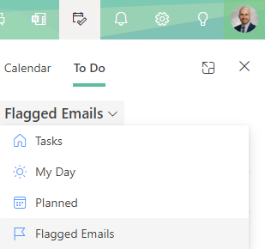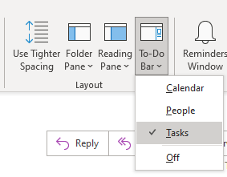

  - You can make your own tasks, or you can assign an email as a Task using the Follow Up Flag
    - You can assign a due date for replying to an email in the Ribbon at the top of your window

Desktop: Web:
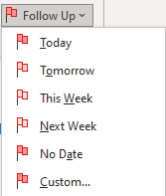
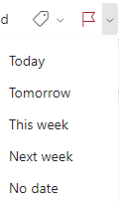

- Meeting scheduling
  - Meetings can be easily scheduled with all participants from an email thread.
    - Tip: Include your Zoom link in “Location” for remote meetings

Web:
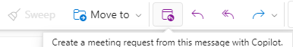

Desktop
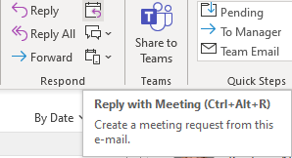

- Foster inclusivity
  - Create a nametag for your email signature that leads to a landing page where the correct pronunciation and any other info you’d like to include is present
    - Go to https://www.name-coach.com/events/name-profile/registrations/new
    - Fill out the information and record your name pronunciation. Once completed, you should be able to view your nametag

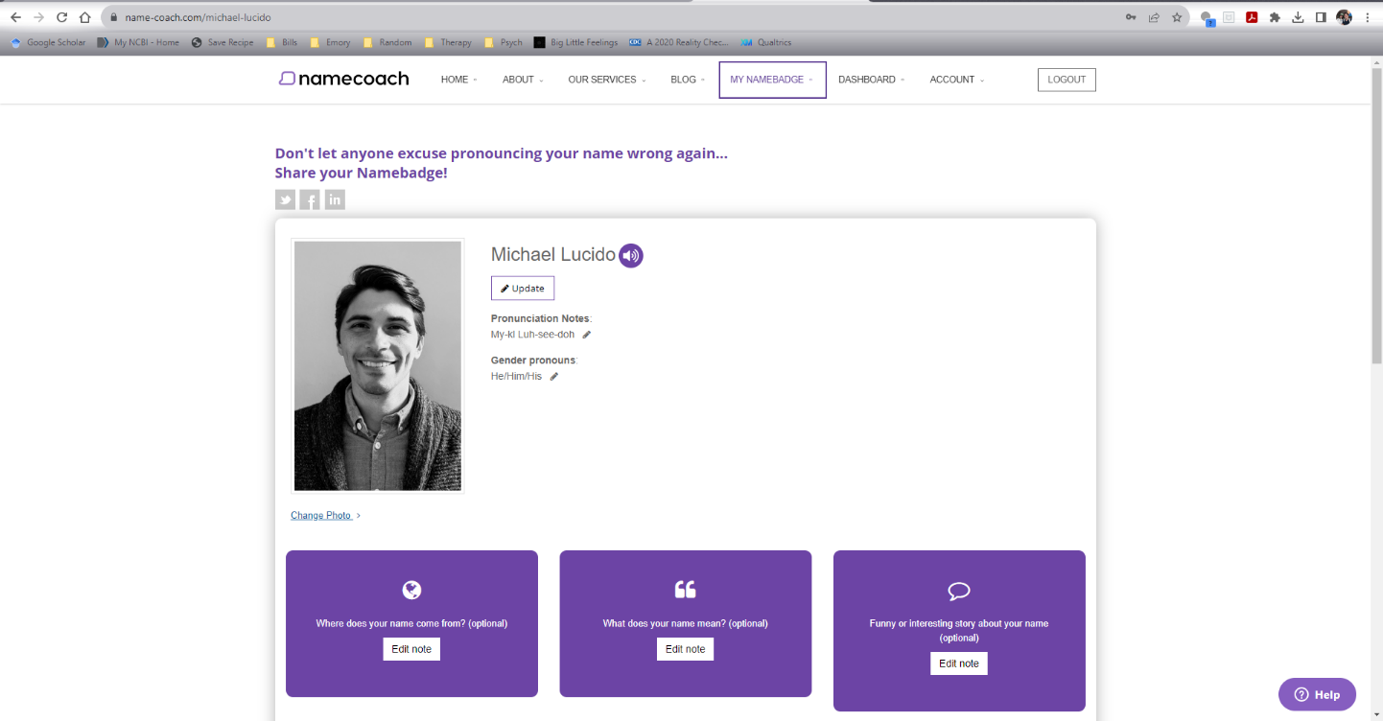

    - If you scroll to the bottom of the nametag page, there is a box with links that can be copied and placed into your email signature on Outlook
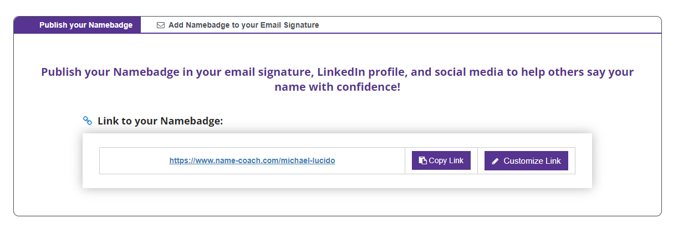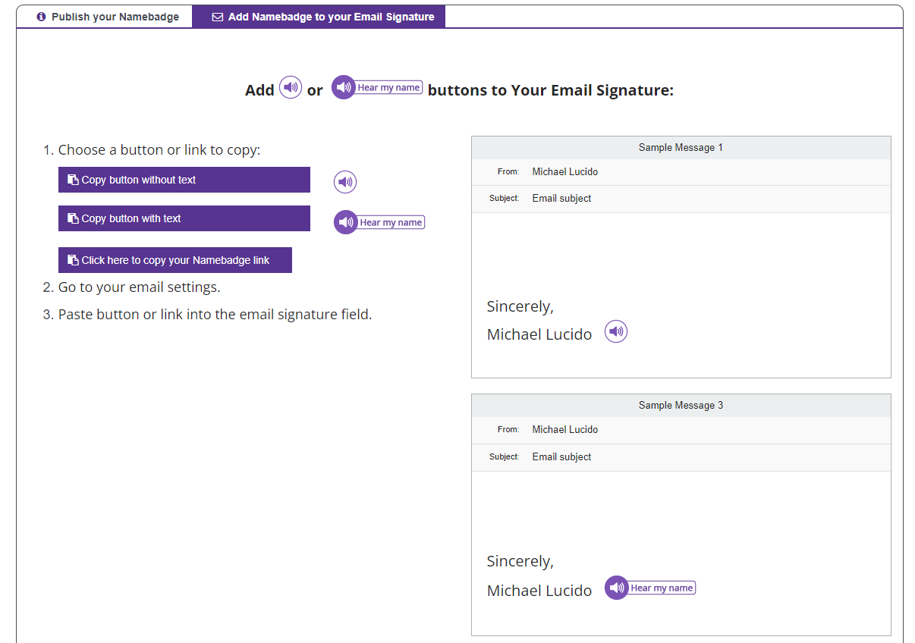
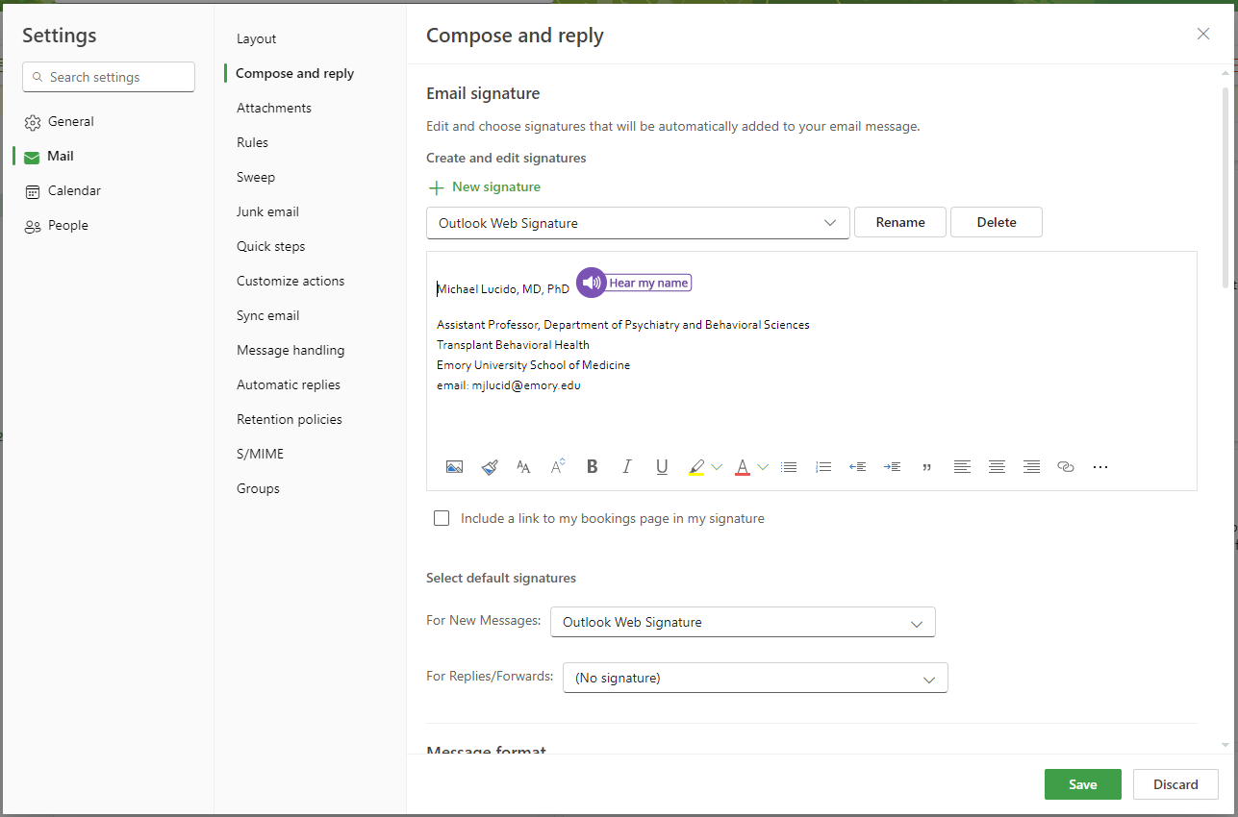

- Templates / Quick Parts
  - It is possible to create canned responses to frequently asked questions or templates that need to be sent frequently (e.g. when a student starts a new rotation with you)

For both updated Desktop Outlook and Outlook Web App:

Step 1. Open a new e-mail

Step 2. Above the e-mail on the far right, click the three dots then go down to “My Templates”
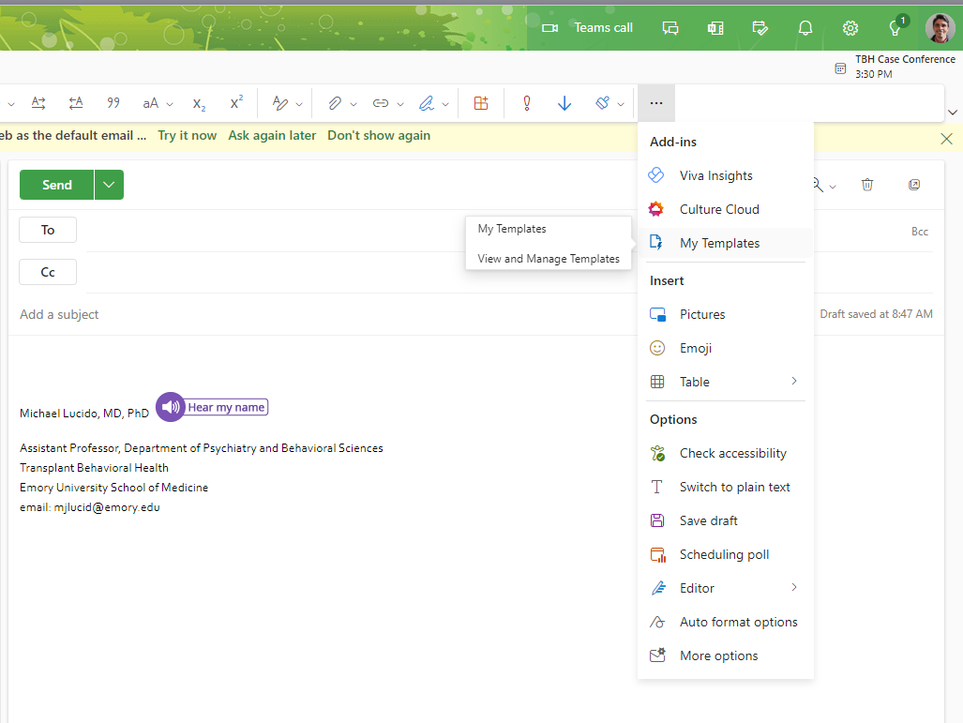

Step 3. A side panel will open where there are some generic canned responses by Outlook, but there is also the option to add a new template

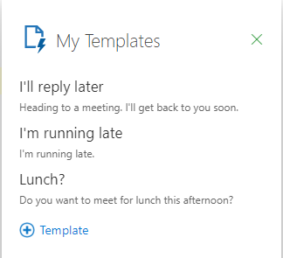
Step 4. Type up your desired canned response or template. If you regularly send documents (like an orientation document, for example), you can upload the document to OneDrive and then copy the link and paste it within the template. Instead of being an attachment to the e-mail, it will be an embedded link the recipient can click.
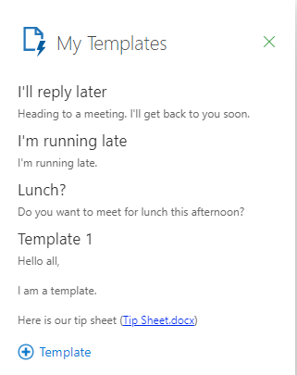

Step 5. After saving the new template will show up in the template list. If you have an open email, click on the template you wish to use and it will populate the email body wherever your cursor is and using whatever formatting (e.g. text size, font, etc) is already set up in your email.
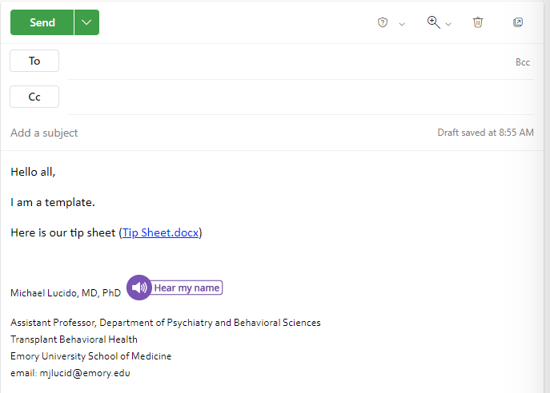
    - For desktop app
      - Essentially the exact same as above, except above the new email there will be a tab for “View My Templates”. Otherwise, the instructions are the same.
