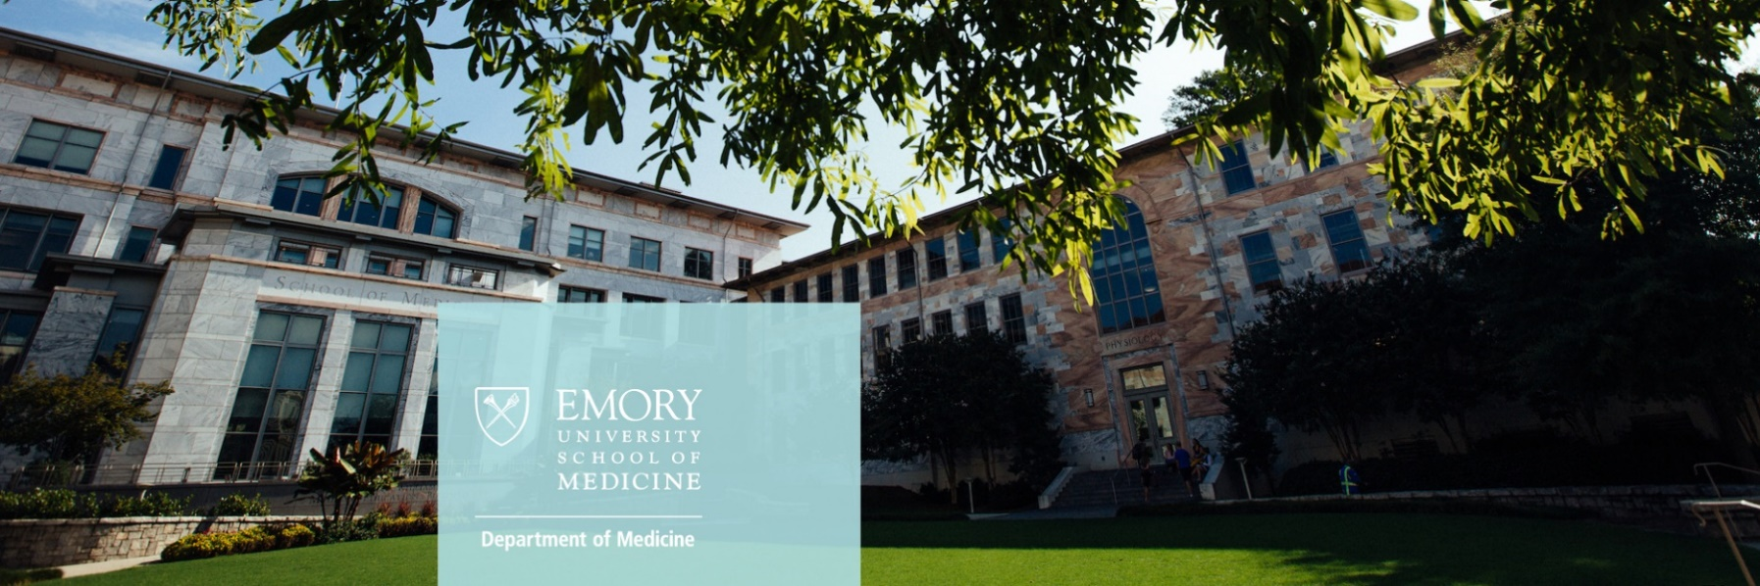

The RYSE Council of the Emory University Department of Medicine invites fourth-year medical students to apply for our Emory University Department of Medicine #RYSE Virtual Visiting Clerkship Program. This clerkship, which specifically targets students who intend to apply to and pursue a career in Internal Medicine (or an IM subspecialty), exposes students to a thriving academic medical center and careers in Medicine.

Accepted students will receive:

* Faculty mentorship
* Exposure to educational activities at Emory in the Department of Medicine
* Virtual exposure to clinical sites at Emory
* Opportunities to meet with residency leaders in the J. Willis Hurst Internal Medicine Residency
* Coaching for interview season

Application requirements and eligibility:

* Current enrollment at an accredited US Medical School
* Anticipated graduation of Spring 2026
* Completion of attached application
* Letter of support
* Current CV or resume
* Official USMLE or COMLEX transcript

***THE EMORY #RYSE VIRTUAL MINI-CLERKSHIP***

**Emory University Department of Medicine RYSE Council**

**Virtual Visiting Students Application 2025**

**Deadline to apply is 7/28/2025**.

Only those with a COMPLETE application by the deadline will be considered for the Emory RYSE Miniclerkship

**First Block: Aug. 11, 2025 – Aug. 22, 2025 | Second Block: Sept. 22, 2025 – Oct. 3, 2025 | SAMPLE SCHEDULE INCLUDED BELOW**

Last Name: First Name:

Cell Phone #: Primary Email Address:

Mailing Address: USMLE 1 Score (please list all attempts, if applicable)

USMLE Step 2 score (please list all attempts, if applicable)

Name of Medical School: Anticipated date of graduation:

Name of Undergraduate Institution

I am applying to Internal Medicine residencies: Preferred rotation block:

Yes No

Are you a [first-generation college student](https://firstgen.naspa.org/why-first-gen/students/are-you-a-first-generation-student#:~:text=Yes.,you%20navigate%20your%20college%20journey!)?

No Yes

Do you have a parent or immediate family member who is a physician?

No

Yes

If you are from a disadvantaged background*, please describe. (250 words max):

*Criteria for a Disadvantaged Background as defined by, *but not limited to*, the HRSA Bureau of Health Professions Workforce:

* Rural environment hometown (population approximately <10k),
* Educationally disadvantaged background: first generation college-educated, or
* Economically disadvantaged background: history of SNAP benefits, Medicaid, or has lived in public housing

Please briefly describe your reason for applying to the program and interest in Internal Medicine (400 words max):

Required Documents (please send electronically:)

Letter of support from an Internal Medicine faculty member at your home institution. This should be directly emailed to us from author.

Attach your resume/ CV.

Terms & Condition for All Participants (your signature below indicates your acceptance):

I agree to all the terms and conditions to the [Emory University School of Medicine Code of Conduct.](https://med.emory.edu/handbook/academics/professional-conduct/conduct-code/index.html)

I agree to participate in the rotation to which I have been accepted during the aforementioned dates and the diversity program activities.

I agree to participate in a cohort based model during my rotation periods. This involves sharing your contact information with other visiting students that have also been selected as recipients for the diversity stipend award.

I understand that this virtual mini-clerkship is not for a grade or credits. I also understand that this experience does not guarantee an interview with the Emory J. Willis Hurst Internal Medicine Residency program.

Student Signature & Date

**SUBMIT COMPLETED APPLICATION AND MATERIALS TO:**

**EMORY DEPT. OF MEDICINE | RYSE Initiatives**

A’Kristionna King | [akristionna.g.king@emory.edu](mailto:akristionna.g.king@emory.edu)

*Program Coordinator, RYSE Initiatives and Human Resources*

Emory University Department of Medicine

Phone: 404-712-3272

**Sample Schedule\***

**Week 1**

|  |  |  |
| --- | --- | --- |
| **Monday** | | |
| 10:00 am – 10:45 am | Welcome (Dr. Kimberly Manning) | Zoom |
| 11:00 am – 11:30 am | Morning Coffee (Dr. Bussey-Jones) | Zoom |
| 11:30 pm – 12:00 pm | Meet and Greet (Dr. Francois Rollin) | Zoom |
| 6:00 pm – 7:00 pm | RYSE Welcome (Dr. Zanthia Wiley, Dr. Jason Cobb) | Zoom |
| **Tuesday** | | |
| 10:00 am – 10:30 am | Morning Coffee (Dr. Karen Law, Program Director) | Zoom |
| 10:30 am – 11:00 am | Chief Check-In with Grady Chiefs | Zoom |
| 11:00 am – 12:00 pm | Preparing for Interviews (Dr. Kimberly Manning) | Zoom |
| 6:30 pm – 7:30 pm | Churchwell Diversity and Inclusion Collective (CDIC) Meet and Greet | Zoom |
| **Wednesday** | | |
| 10:00 am – 10:30 am | Morning Coffee (Dr. Jennifer Swails) | Zoom |
| 10:30 am – 11:00 am | Clinic Meet and Greet (TBD) | Zoom |
| 11:00 am – 11:45 am | Teaching Session (Dr. Francois Rollin) | Zoom |
| 6:30 pm – 7:30 pm | RYSE and Shine with RYSE VVSC Alumni | Zoom |
| **Thursday** | | |
| 9:30 am – 10:30 am | Chief Check (Dr. Kaki Bennett) | Zoom |
| 10:00 am – 10:30 am | Morning Coffee with Program Coordinators | Zoom |
| 10:30 am – 11:00 am | Morning Coffee (Keia Dodd, GME Office) | Zoom |
| 11:00 am – 11:45 am | Teaching Session (Dr. Mikhail Akbashev) | Zoom |
| 6:30 pm – 7:30 pm | What it’s like: I trained at Emory  Emory J. Willis Hurst Residency Program Alumni | Zoom |
| **Friday** | | |
| 10:00 am – 10:30 am | Morning Coffee (Dr. TaRessa Wills) | Zoom |
| 10:30 am – 11:00 am | Chief Resident Check-In (Dr. Kevin Rymut) | Zoom |
| 11:00 am – 11:30 am | Teaching Session (Dr. Alex Galloway) | Zoom |
| 12:00 pm – 1:00 pm | Regroup and Close the Loop | Zoom |

**Week 2**

|  |  |  |
| --- | --- | --- |
| **Monday** | | |
| 10:00 am – 10:45 am | Teaching session (Dr. Youssef Saklawi) | Zoom |
| 11:00 am – 11:30 am | Morning Coffee (Dr. Shelly-Ann Fluker, Primary Care Program Director) | Zoom |
| 11:30 am – 12:00 pm | Morning Coffee (Dr. Dheepa Sekar) | Zoom |
| 6:00 pm – 7:00 pm | Distinctions in Teaching (Dr. Shub Agrawal) | Zoom |
| **Tuesday** | | |
| 10:00 am – 10:30 am | Morning Coffee (Dr. Colin Washington) | Zoom |
| 10:30 am – 12:00 pm | Mock Interviews (Dr. Kimberly Manning) | Zoom |
| 6:00 pm – 7:00 pm | Continuity Clinics (Dr. Alex Galloway and Dr. Kaki Bennett) | Zoom |
| **Wednesday** | | |
| 10:00 am – 10:30 am | Morning Coffee (Dr. Stacy Higgins ) | Zoom |
| 10:30 am – 11:00 am | Morning Coffee (Dr. Mehul Tejani) | Zoom |
| 11:00 am – 11:45 am | Teaching Session (Dr. Khaalisha Ajala) | Zoom |
| 6:30 pm – 7:30 pm | Subspecialty Life: Fun with Fellows and Friends | Zoom |
| **Thursday** | | |
| 10:00 am – 10:30 am | Morning Coffee (Dr. Michael Kimbrell) | Zoom |
| 10:30 am – 11:00 am | Morning Coffee (Dr. Karen Law) | Zoom |
| 11:00 am – 11:30 am | Teaching Session (Dr. Shub Agrawal) | Zoom |
| 2:00 pm – 3:00 pm | Bringing Your A-Game (Dr. Kimberly Manning) | Zoom |
| 6:00 pm – 7:00 pm | Residents as Researchers (Dr. Lesley Miller and Dr. Sara Turbow) | Zoom |
| **Friday** | | |
| 10:00 am – 10:30 am | Morning Coffee (Dr. Wendy Armstrong) | Zoom |
| 10:30 am – 11:00 am | Closing the Loop (Dr. Kimberly Manning) | Zoom |
| 11:00 am – 11:30 am | Program Evaluation (A’Kristionna King) |  |

*This is a sample schedule. Events and names are subject to change.